Lab 8

IPv6

**Objective 1: OSPFv3**

(Clear the MPLS configurations from previous lab and make the changes to topology as shown)

ARIN has assigned 2005::/48 for your company (Company X). Read the following

information about Company X and keep them in mind:

1) All the routers have dual stack (v4/v6) implemented in them.

2) R2, R3, R4 and R5 are running OSPFv3 - area0.

3) R4 and R6 are running OSPFv3 – area1.

4) R1 and R2 are running RIPng

5) YouTube and Yahoo (loopbacks) are dual stack - IPv4/IPv6

6) Customer X, PC A and PC B have only IPv6.

Following objectives must be met:

1) Assign only IPv6 addresses to PC A, PC B and customer X and all the interfaces from the

block provided by ARIN. Paste screenshots of the IP addresses assigned.

2) Use some other IPv6/IPv4 block (than Company X) for Yahoo and YouTube. Paste screenshots of the IP addresses assigned.

3) Run OSPFv3, RIPng according to above information so that the company has end-to-

end intra company connectivity (includes all loopbacks and PCs). Paste relevant screenshots.

**Objective 2: DHCPv6**

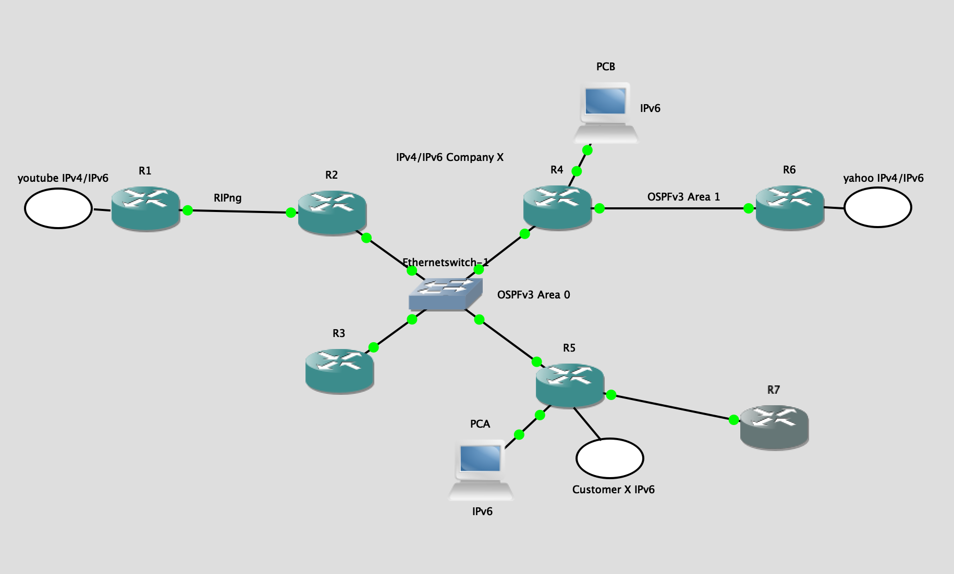

In the above objective you assigned your IPv6 addresses manually. Here you would

need to use DHCPv6.

1.Assume R7 belongs to the ISP X. ISP X has allocated the subnet 2005::/48 to

Company X (remove the static IP addresses from R5 and PC A that you had

assigned in the first objective) and will be assigning this subnet through DHCPv6.

2.You need to get R7 to provide an IP from the 2005::/48 subnet to your R5

router’s public interface.

3. The prefix should propagate on to PC A. Paste a screenshot of the IP address obtained by PC A.

The following document will help you set up the DHCP configurations:

<https://www.cisco.com/c/en/us/products/collateral/ios-nx-os-software/enterprise-ipv6-solution/whitepaper_c11-689821.html>

**Objective 3: IPv6 Tunneling**

Remove the R7 router and add R8 and R9 routers as shown in the figure. R8 is a part of company Y and R9 is a part of company Z.

Company X wishes to connect to Company Z. But as company Y is only IPv4 compatible,

company X can talk to company Z only via IPv6 tunneling. ARIN has given 2010::/48 to

company Z. NOTE: routers only in company X and company Z are dual stack.

Achieve the following objectives in order:

1. **Objective 3.1: ISATAP tunneling**

As company X is connected to company Y now, company X wishes that PC A should

always be able to connect to PC B even when the switch link fails. This will be

achieved via setting up a tunnel 0 (ISATAP tunnel) between R4 and R5 through R7.

Follow the conditions given below to achieve PC A and PC B connectivity via tunnel0:

i) Use only 10.0.0.0/16 IPv4 addresses for all the links coming out from R8.

ii) R8 (being in company Y) should never have any IPv6 configurations.

iii) Use RIPv2 to get IPv4 connectivity between all the routers –R4, R5, R8, R9.

iv) Tunnel 0 must be of mode – ISATAP. Therefore, carefully assign IPv6 addresses to

the tunnel interfaces.

v) Run OSPFv3 on tunnel 0.

Once your tunnel is up, make sure that PC A should still talk to PC B via

tunnel 0 (fail switch link between R4 and R5).

1. **Objective 3.2: 6to4 tunneling**

Now that Company X has link redundancy, it wishes to take a new step by getting

connected to company Z. Somebody decides that the connectivity should be achieved

via 6to4 tunneling (called as tunnel 1). Follow the conditions to

get end-to-end connectivity between the two companies:

i) Achieve full IPv4 connectivity between Company X, Y and Z.

ii) R8 should not have any IPv6 configurations.

iii) As ARIN assigns a 2010::/16 prefix for company Z, use it for intra network (i.e. link

between PC C and R9).

vi) Tunnel 1 must be of mode – 6to4. Therefore, assign carefully IPv6 addresses to the

tunnel interfaces. After your tunnel is up, get complete connectivity. i.e. between companies X and Z (Yahoo, YouTube, and all other PCs). What do you notice? Do you still have connectivity between PC A and PC B via tunnel?

1. **Objective 3.3: Manual tunnel**

Now that the companies realize that, one cannot run ISATAP and 6to4 over same

interface, they decide to run a manual tunnel from R4 to R9 for connecting

company X and Z via company Y.

i) Create a manual tunnel 2.

ii) Use IPv6 address for tunnel 2 from Company X’s IPv6 pool.

iii) Run OSPFv3 on tunnel2.

Finally, get full v6 connectivity between all the PCs (and loopbacks).